**Anomaly** **Detection in Credit Card Transactions**

Power BI Desktop

631K

6.42M

383

10.00M

0.06

3.58M

**isFraud** 0 1

40,000M

Sum of amount

20,000M

0M

## nameDest Count Of Fraud Transactions

V

## C185805228 2

## C200064275 2

## C410033330 2

## C1002031672 1

## C1007251739 1

## C1009459055 1

## C1009564356 1

## C1009901500 1

## C101179743 1

**Total** **383**

10M

5M

8bn

6bn

Sum of amount

4bn

2bn

0.3bn

7.1bn

7.3bn

5.5bn

0.0bn

### 161.5K (15.48%)

### 881.59K (84.52%)

## Avg Frau… Avg Nor…

## nameDest Highest Number Of Transaction

V

## C985934102 95

## C1286084959 89

## C248609774 87

## C2083562754 85

## C665576141 85

## C1590550415 83

## C977993101 80

## C1360767589 79

## C451111351 76

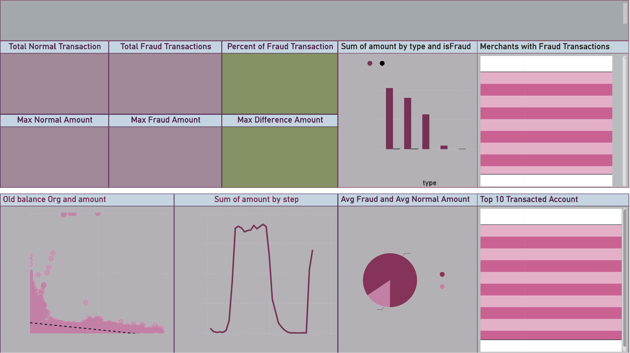0M

amount

0M 20M 40M

# oldbalanceOrg

0bn

0.0bn

0

20 40

# step

## C306206744 75

**Total** **834**